11th ANNUAL VENDOR SHOW

May 28th - Sioux Falls Sheraton Convention Center

Vendor Table Registration Form

Company Name_____________________________________

Who will be attending? _______________________________

Number of tables needed? 1 2 3

Tables Pricing
$350 each if paid by May 4th, 2015
$425 each if paid after May 4th 2015

Please fill out this form and send it with a check* to:
Midcontinent Communications
3901 N Louise Ave
Sioux Falls SD 57107
Attn – SCTE Vendor Show – Cherri Olson

*Make the check to - Dakota Territory Chapter of the SCTE.

CREDIT CARD PAYMENT - To pay by credit card, send a request to dakotachaptervendorshow@gmail.com or Cherri Olson a cherri_olson@mmi.net

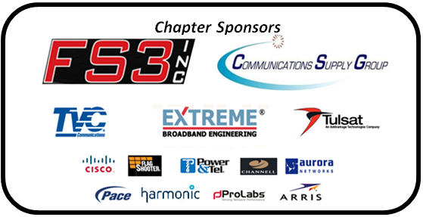

"Contributions or gifts to the Society of Cable Telecommunications Engineers, Inc. are not deductible as charitable contributions for federal income tax purposes."

